**Time Tested: Proposal**

**Members:** Itay Bernstein & Avital Gordin

**Summary**

The players are volunteers for a lab experiment run by 2 scientists studying the possible uses for time manipulation. The experiment puts the players' problem-solving abilities to the test and allows them to use gadgets developed by the scientists to progress in the game. This game is all about solving puzzles, defeating enemies, and clearing different stages in a multiplayer setting. The multiplayer aspect of the game will run on a cloud service. Many of the game's mechanics can be controlled by voice commands.

**What Makes the Game Unique**

The unique aspect of the game is the ability to manipulate time in a multiplayer setting and use voice commands to activate said time-related powerups. These powerups are used to manipulate and complete the game's levels. The game will also include narration dialogue that will help immerse the players into the plot of the game and make it a fun experience. Thanks to the multiplayer features, players will be able to invite their friends to join their game and cooperate through different puzzles together.

**Similarities and Differences with Other Existing Games**

A few games use similar ideas and features that allow the player to manipulate time. One of them is a game called Braid, which was released in 2008. However, the game has a few differences compared to our idea; Firstly, the game is in single-player mode. In addition, when rewinding time in Braid, all objects on screen, including the player, are affected. In our game, certain objects will be interactable using time-manipulation and other power-ups. Lastly, the plot of Braid is entirely different from ours, while our game is about scientists using the players as lab rats for experimentation, Braid is an adventure game about saving a princess from a monster.

**Gameplay/Flow of Users in the Game**

The game is aimed at people who want to solve problems and puzzles, are interested in the concept of time manipulation, and want to cooperate and work together with other players.

Upon starting the game application, the player will be met with a main menu where they can join a game, change game settings, or quit.

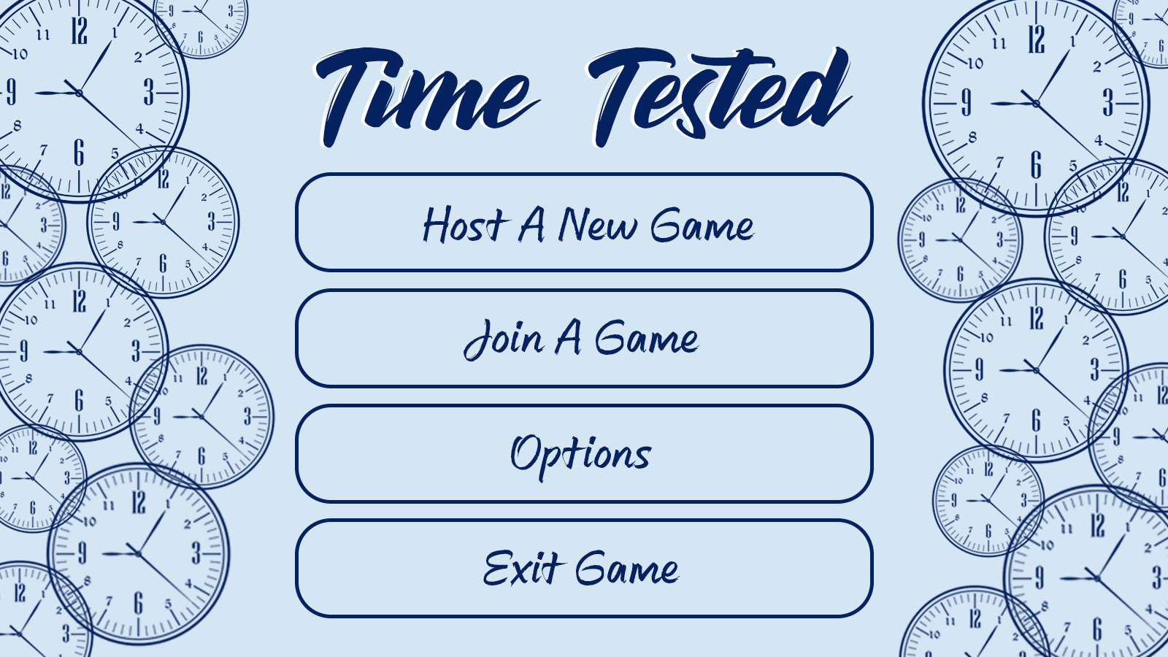

There will be a lobby where players can wait for the game to start, accommodating up to 3 players.

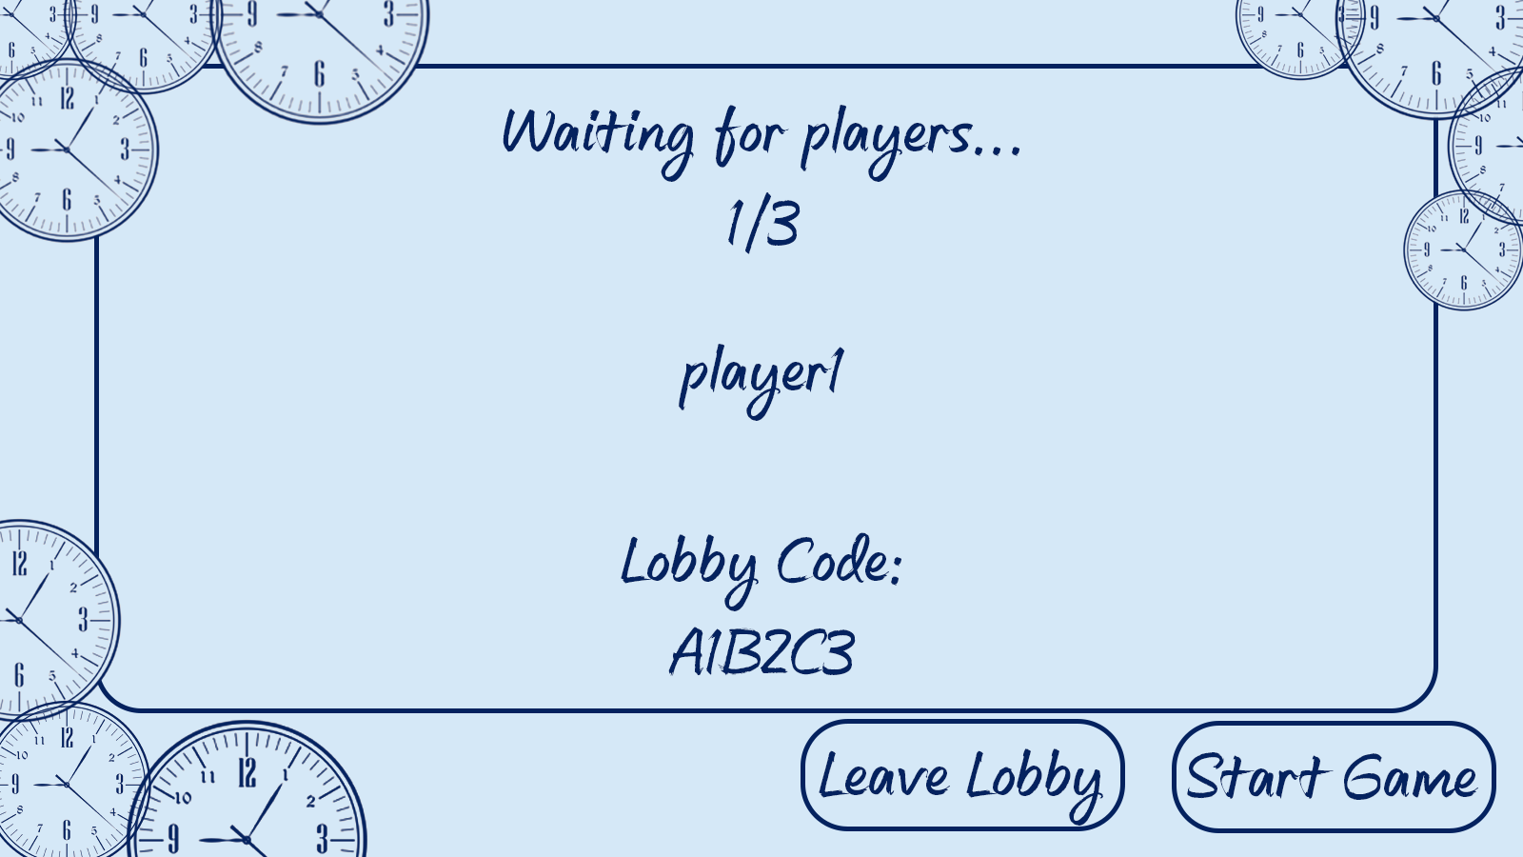

After starting up the game, the players will be familiarized with the different mechanics, primarily showcasing the various power-ups available throughout the game’s levels. The 2 scientists will narrate them through the tutorial to explain each mechanic.

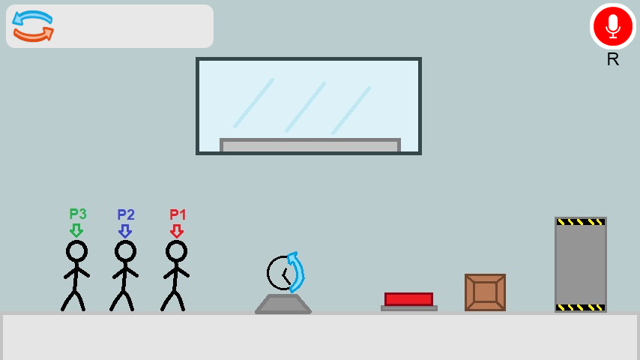

Afterward, the players will advance through different rooms/levels with puzzles and enemies in them and will have to use teamwork and the game’s mechanics effectively to clear them. The 2 scientists will occasionally interject with narration according to various game triggers.

**Main Project Features:**

**“Time-Manipulable Objects”:** The game will feature objects in levels that are affected by time manipulation power-ups (will be elaborated on below). When such power-ups are used, all time-manipulable objects on the screen will be affected. Players are not time-manipulable.

**Enemies:** Some levels will have enemies in them that will be hostile towards the players and try to attack and kill them. All enemies are considered “time-manipulable”.

**Power-Ups:** The game will feature power-ups that will be used to complete the puzzles.

Here are the various power-ups that will be scattered throughout the game:

* **Time Rewind:** When used, will rewind time for all time-manipulable objects onscreen (including enemies, as was mentioned), bringing them back to a past state and position.
* **Time Stop:** When used, will stop time for all time-manipulable objects onscreen. These objects will be frozen for a certain amount of time. Time Rewind will not take into consideration the positions and states of objects/enemies during Time Stop and will skip over them.
* **Superweapon:** The game will feature a “superweapon” power-up (undecided what kind of weapon it will be, but it will be destructive). This superweapon will be very effective against enemies and will be able to destroy time-manipulable objects.
* **Clone:** When used, the player will create a clone of themselves in their exact position. Can be used to keep buttons pressed. In addition, enemies will be distracted by the clone, targeting it instead of the players. The clone will have its own health bar. When the health bar depletes entirely, the clone will disappear. The power-up can be used again to destroy the clone manually. The clone is time-manipulable.
* **Swap Position:** When used, the player will swap position with a targeted object/enemy. The player will have to target an object/enemy beforehand in order to use it.

**Voice Commands:** All power-ups in the game will be able to be activated using voice commands. The voice command for Time Rewind will include a parameter, for example, "Time Rewind **five** seconds."

There will be an option not to use voice commands.

**External Dependencies:**

**Unity:** The game will be developed under the Unity game development engine.

**Voice-to-Text:** This project will use a service/framework to send voice recordings and receive their transcript to facilitate voice commands.

**Cloud service:** This game will have its multiplayer component run on a cloud service.